SDA Implementation Ideas
Timofei Bolshakov, Dennis Nicklaus, Elliott McCrory
31 July 2026

Introduction
In this document, we elaborate on a possible implementation for Sequenced Data Acquisition (SDA) data acquisition (DAQ) for the LHC, and give some details on the structure of the data flow and the XML documents that are internal to SDA. First, we review and expand the relevant SDA terminology
- “Shot”— the name for the entire process that is being recorded. The shot is designated by a sequence number, which is the index into the data storage for that instance of the process. This term is also called a “store” or a “file.”
- “Case”— the stage within the shot. A case has a descriptive name and an index number. A case generally occurs once and only once within a given shot (but see “stored over”, below). The order of the cases is usually repeated in each shot, but this is not necessary. Nor is it necessary for every case to the present in every shot.
- “Set”— a further temporal division within a case. A set is designated by a sequence number. The number of sets can be fixed (as in the number of proton bunches that are injected, one set per injection (if that is relevant)), or variable (for example, a new set may be generated every ten minutes during the physics portion of a store). A Set is represented by a Collection; one set = one collection.
- “Event”— the time or the condition for data collection. This can be a hardware event generated by the system clock or a set of conditions that are met, for example, in software. An event usually marks the beginning of a shot or a case and is necessary to trigger the acquisition of a “collection.”
- “Collection”— the list of “atoms” that are to be acquired on an event.
- “Atom”— the datum that is to be collected. It is up to the facility to define the types of atoms that are relevant. These include “device” (a scalar reading or an array of readings from a specific accelerator component or sensor), “snapshot” (a fast chunk of data collected at a specific machine time) and “fast-time-plot” (a series of readings from a device over a short time period). Other types of atoms could be, for example, “image”, “movie” or “post-mortem-datum”. Every atom in a collection has an Event on which it should be read.
Store, Case, Set and Event are the temporal (and logical) abstractions, while Collection and Atom are the data abstractions.

Data Acquisition
The first area in which we present some implementation details/ideas is the data acquisition. Getting shot data into the SDA database can occur in a number of ways, the most prominent is direct acquisition from the machine devices in the complex. DAQ is based on gathering the data at the time markers defined for the shot (the Case and the Set). The lists of data are organized into Collections, and the Collection times are governed by the Events of the accelerator. Here are terms related to the events that drive the DAQ:
- Arming Event –The time at which we begin waiting for the actual event that causes the start of a particular case or a shot. Also, the time at which the header information in the database for this shot or case is written. The header records relevant information about the item, for example, the shot start timestamp, the case stop timestamp, etc. It is not completely necessary to have this event, but it is preferred. (Cases in Fermilab SDA do not have headers yet.) The arming event can be “immediate,” that is, as soon as the preconditions are met an arming event can be (logically) issued.
- End Event – All DAQ is stopped, and no further DAQ can be initiated for this shot/case/set. If an End Event fires and stops and set or a case, then this is an error condition.
- Disarming Event –When a disarming event is issued, it waits for pending acquisitions to complete, but no new data collection processes are started.
- Set Start Event – an event that starts a Set/Collection.
- Set Stop Event – an event that ends a Set/Collection. If a Collection has a Stop Event, then that Collection’s Data Acquisition tasks stops collecting data when the event fires. If a Collection does not have a stop event, then it will stop itself when it finishes collecting the data.
All events can be automatically generated (logically, within SDA) when all the appropriate preconditions are met. For example, the first set of a case can start as soon as the case begins.
At Fermilab, we implemented each of these events redundantly. That is, there are two events possible that can trigger any one of these. This was added to allow a new event to be inserted gradually. In other words, an initial idea for an Arming Event for, say, a case may be abandoned in favor of a more sophisticated event trigger, but the old event continues to operate until the new event is fully implemented and debugged.
A diagram depicting a fictitious ramp cycle, meant to complement these definitions, is presented here.
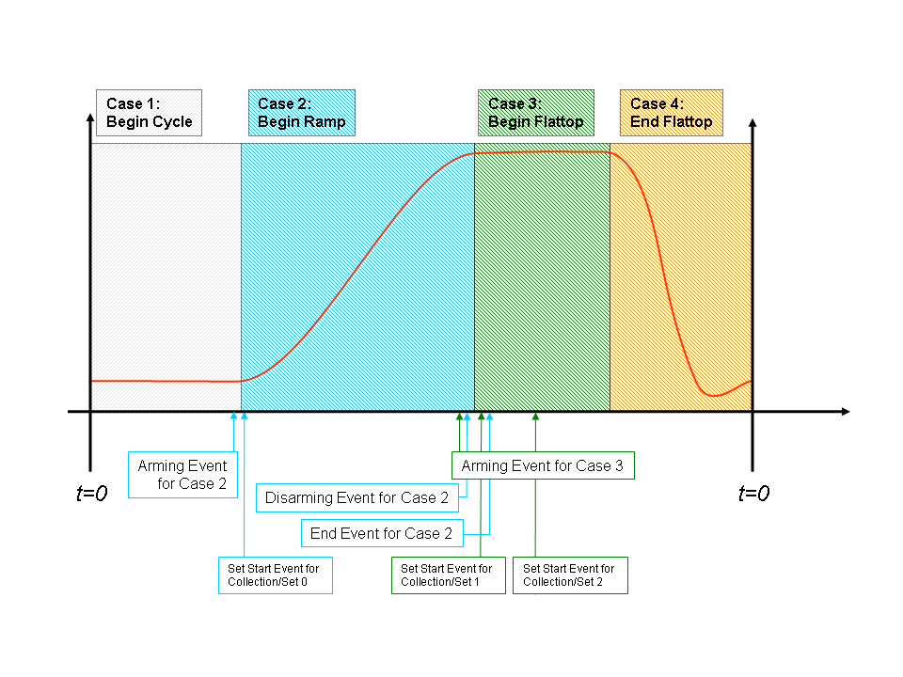
The time definitions of cases can be modified as follows:
- Multi-Sets Cases – Cases that may have more then one set. In our system the set numbers of Multi-Sets Cases start at 1. If the Multi-Set flag is false, then there is only one Set, and it is numbered 0. There can be several Collections with the same set number; the final one is considered to be the “valid” or “successful” one, the older ones are called “stored over,” as defined below.
- Concurrent or Multi-Collection Cases – Cases that can overlap the beginning of the next case. This allows collections within the previous case to finish even if the next case has started. If the “concurrent” flag is set to false (“Monopolizing”), then it forces other collections to stop after receiving an arming event. (This is one reason why SDA DAQ is not strictly a finite state machine.) At Fermilab, examples of concurrent cases are our proton and pbar injection cases. Data Collection can take longer than the injection itself. Moreover, several cases can describe the same process (“Inject Protons”, “Inject Protons: Booster to MI”, “Accelerate Protons in MI”). Thus, several cases may be active simultaneously if they all are concurrent.
SDA can be run in a test mode, to run through the cycle in order to test the data acquisition. This was useful at Fermilab during the initial startup of the Tevatron Collider.

Roughly, an algorithm for the data acquisition for SDA looks like this (this is pseudo-code fashioned after the Java syntax):
function SdaDataCollection(){
// SDA properties relevant here: shotTypeN
listenOnEvent( shotDisarmEvent, { // Pseudo code to register an event handler
stopAllCurrentCollectionsOfThisShot(); // For this, to deal with start of a shot
closeTheShot();
markDuplicatedSetCollections(); // See notes, below.
});
listenOnEvent( shotArmEvent, {
determineShotAliasAndIndex();
// SDA properties relevant here: shotTypeN, shotN, shotIdx
writeShotHeader();
readAndInitializeAllCases(); // optimization and consolidation would occur within this function
// we are a little imprecise here…
forEveryCaseConcurrently ( listenOnEvent( caseArmingEvent, processCase() ) );
} );
function processCase() {
// SDA properties: caseN, shotTypeN, shotN, shotIdx
writeCaseHeader();
if ( !concurrent ) stopAllCurrentCollections();
if ( caseDisarmingEvent != null ) // If case disarming events are relevant
listenOnEvent( caseDisarmingEvent, stopAllCurrentCollectionsOfThisCase() );
while( notDisarmed )
listenOnEvent ( setArmEvent, { sn = determineSetNumber(); processCollection( sn ); });
}
function processCollection( sn ){
// SDA prop's: setN, caseN, shotN, collectionIdx, shotIdx, shotTypeN
writeSetCollectionHeader( );
DeviceRequest [] deviceRequests = getDeviceRequests();
Events [] events = getEvents();
forEveryEventRequestPairConcurrently( // Can be consolidated into jobs here.
listenOnEvent ( events[i], write( collectDevice( deviceRequests[i] ) ) ) );
}
}
The functions underlined like this are part of the DAQ interface/plugin.
The functions underlined like this should be implemented as generally as possible, probably as scripts.
The functions underlined like this are part of the database interface/plugin.

DAQ Notes
- SDA DAQ and database implement a concept we call “stored over”. A shot, case or set is stored over when that step is repeated for any reason. This is generally an operational decision. The most common “stored over” item at the Tevatron is the sets within the “inject protons” case. The proton bunches are injected one by one (one per set), and are rejected if the size of the injected bunch in the Tevatron falls outside of a predefined range. We typically do about forty proton injections to get the 36 bunches we need. The data from the extra sets are marked as “stored over”, and the set is repeated. Most views into the SDA database ignore items that are marked in this manner, but it is possible to see these data. This is particularly important during the initial commissioning in order to review the things that went wrong. So, “markDuplicatedSetCollections()” performs this database operation, that is, marking the items that are “stored over”. In practice, the internal index for that shot/case/set is incremented and the largest index for the step in question is returned, unless one particularly wants to see the stored over values.
- The SDA variables available at given level are defined here:
- setN – Set Number
- caseN – Case Number (the Case Name is obtained from the structure database)
- shotN – Shot Number
- shotIdx – Shot Index. Two shots may have the same shot number. In this case the older shot is an “over shot”. The unique index in the SDA database is provided by this variable.
- collectionIdx – Collection Index. Two sets may have the same set number. In this case the older set is marked as an “over set”. This number is the unique SDA database index.
- shotTypeN – Shot Type Number.
- determineSetNumber() – The implementation of this function may vary considerably for different sorts of sets, and it is often necessary to easily change the implementation. For example, in the “Inject Protons” case at Fermilab, the set number corresponds to the transfer number. For the “HEP” case, the set number is incremented every 10 minutes.
- listenOnEvent() –Wait for the event(s). When one of them has happened, it should call the method provided as second argument. In the normal Java fashion, this call registers the event to listen for and the event handler that should be called, and it returns immediately.
- There are many possible optimizations and consolidations. These have been omitted for clarity.
- Several functions in this snippet should probably be implemented as scripts, for example determineSetNumber(). – This one is relevant because (as discussed above) the implementation will probably be different for different shots types / cases numbers, and the ability to easily change the implementation is beneficial.
- closeTheShot(), markDuplicatedSetCollections(), getDeviceRequests(), getEvents(), readAndInitializeAllCases() also may / should use database operations, provided by database plugin. closeTheShot() and markDuplicatedSetCollections() – write and read, getDeviceRequests(), getEvents(), readAndInitializeAllCases() - read only.

SDA Data Flow
All data flow within SDA is assumed to be in the form of XML documents. It is important to understand the boundaries of SDA, as communications outside of SDA are not constrained to be in XML. A schematic diagram of the components of SDA is shown in this figure.

The dotted blue line within the light blue SDA box represents the XML communications among the various components of SDA.
The communications with the database within SDA is done with XML documents. This can be accomplished with a native XML database, or by writing translation routines at the periphery of the database. An XML database provides an enhancement in the data flow as the data are somewhat more complex than a standard relational database. From the previous document, here is the XML schema for communications with the database.

<shot type='1' alias='4008' index='8672' ...>
...
<case name='HEP' alias='14' ...>
...
<set alias='25' collection_index='425' ...>
...
<atom name='C:B0ILUM' time='...' type=’scalar’>
... Data for the C:C0ILUM atom...
</atom>
<atom name=’ScopeTrace_01012342’ time=’…’ type=’snapshot’>
Data for this snapshot, probably encoded as an ASCII stream…
</atom>
...
</set>
...
</case>
</shot>
The XML tag gives the information that is necessary to describe the tag itself (attribute) and the contents of the tag contain the data for that tag. For example, the atom tag contains actual data from an accelerator device, in addition to the description of the atom itself. The set tag contains atoms, the case tag contains sets, and the shot tag contains cases.
Data requests to the database are done with XQuery [see http://www.w3.org/TR/xquery/ for the full specification of XQuery, and http://www.w3schools.com/xquery/default.asp for a nice tutorial on using XQuery]. A query on the above document might look like this:
doc("ColliderShot_8672_4994.xml")/
shot[@index=8672]/
case[@alias=14]/
set[@alias=25]/
atom[@name=”ScopeTrace_01012342”]

(New lines have been added after the slashes here to enhance readability.) Each shot is a separate XML document, stored in the database. More complex queries can be constructed, of course.
Similarly for the description of the data acquisition:
<structure>
<owner id='{0,1,2,3}' name='{ColliderShot, ...}' test='B' current='true'>
<case alias='N' name='Name' mult-collection='B' mult-sets='B' arm1='E' arm2='E' disarm1='E' disarm2='E' set1='E' set2='E' end1='E' end2='E'>
<atom name='name1' type='{device, snapshot, fast-time-plot, ...}' desc='description' request='device-str' event='Event'/>
...
</case>
...
</owner>
...
</structure>

Conclusions
We have attempted to elaborate on a possible implementation for SDA data acquisition, and to provide some details on the XML document structure for SDA. All of these details have been implemented in the version of SDA that we are working on at Fermilab, but any of these details can be modified to suit the requirements of SDA at LHC.

Contact Information
Elliott McCrory, 630-840-4808, mccrory@fnal.gov
Timofei Bolshakov, 630-840-8034, tbolsh@fnal.gov
Dennis Nicklaus, 630-840-6410, micklaus@fnal.gov

These definitions may reflect the Fermilab bias of the authors. As with all of the implementation details, the nature of these details are subject to discussion, review and change as the nature of SDA for LHC becomes more concrete.

