Functional Specification
Radiation monitoring for equipment in the LHC tunnel
Abstract
One of the most significant radiation hazards to equipment in the tunnel are instantaneous failures due to single event errors and gradual degradation from total dose and displacement damage effects. The considerable uncertainty on the radiation environment in the tunnel and on the radiation tolerance of equipment may result in a reduction of the operational efficiency of the LHC. The radiation monitoring system will help to reduce this uncertainty by providing an early warning as the radiation levels at the location of the equipment increase.
Prepared by :  T. Wijnands [TS/LEA]  [thijs.wijnands@cern.ch] |  |  | Checked by :  E. Tsesmelis  R. Schmidt  K. Potter  P. Proudlock  D. Forkel-Wirth  P. Ciriani  J. Wenninger  R. Denz
History of Changes
Rev. No. | Date | Pages |  | Description of Changes

Table of Contents
1. Introduction 4
2. SCOPE 4
3. Radiation Environment 5
3.1 origins of prompt and remnant radiation 5
3.2 Complex Radiation field 5
3.3 Parametrisation 6
4. Radiation along the ring 6
4.1 global distribution 6
4.2 Local distribution - ARCS 7
4.3 Local distribution – DS 8
4.4 Local distribution – RR 9
5. Functional specifications 9
5.1 Physical units 9
5.2 INaccuracy, resolution 9
5.3 heavy ions 10
5.4 layout and number of locations to be monitored 10
5.4.1 Global layout 11
5.4.2 Local layout 11
5.5 Data handling 12
5.5.1 Calibration and settings 12
5.5.2 Data processing 12
5.5.3 Graphical interface 12
6. References 12

Introduction
Most of the electronic equipment for the LHC machine will be installed in the tunnel and in the underground areas. In many of these areas, the levels of prompt and remnant radiation will increase with time and with it the risk of radiation damage to equipment.

For organic materials such as cable insulation, radiation damage is to a large extent proportional to the dose and independent on the type of radiation. For inorganic materials such as electronics and metals, the induced radiation damage depends mainly on the energy and the type of the particles.

The risk of having radiation induced failure in the LHC is considerable because the amount of electronic equipment is large (approximately 10.000 crates under the main magnets) and because all electronic systems are made of commercial-off-the-shelf (COTS) components that are not radiation hardened. On the other hand, the radiation levels at the location of the equipment in the tunnel are known with a limited accuracy because this depends to a large extent on how well we can predict future operating scenarios and machine conditions.

The radiation monitoring system aims at reducing the risks and uncertainties mentioned above by measuring the radiation levels at the location of the equipment, by evaluating the performance of equipment under irradiation and by determining whether the equipment could have experienced radiation induced failures.

Comparison of simulated and measured radiation levels at the location of the equipment will provide inside in the way the machine is operating. This may be used to improve the efficiency of the shielding structure and define a time scale on which additional shielding should be implemented as luminosity is increasing. It may also help to locate abnormal vacuum conditions, beam losses, alignment errors or faulty corrector magnets.

In the case of radiation induced failures, the monitoring system will provide information on the type of radiation damage that caused the failure. This information can be used to select other components and to verify the with a radiation test in a dedicated test facility.

As the level of radiation levels experienced by the equipment in the tunnel are increasing, the measurements of the total dose and neutron fluence can be used to decide upon preventive maintenance.

SCOPE
The system covers the LHC tunnel and some of the adjacent underground areas such as UJs, UAs, REs and RRs where electronic equipment will be installed. The initial spatial distribution along the ring will be based on the simulated radiation levels but will evolve as we learn more about operating the LHC.

The system does not cover the transfer lines TI2 and TI8. The coverage of the LHC experimental caverns will be treated in a separate document.

The monitoring system is not intended to protect personnel.

The system will not be connected to the interlock system nor will it trigger the beam dump.

The radiation monitoring system can generate an alarm in the control room if the neutron flux or the dose rate exceeds a predefined level at a certain location. This would give the engineer in charge the opportunity to act.

On line information on the hadron flux along the accelerator ring will be made available in the control room. The evolution of the flux, the fluences and total dose as a function of time will be stored in a database and will be available for off line analysis.

Radiation Environment

origins of prompt and remnant radiation
When there is a circulating beam, the stopping of high energy protons will initiate reactions in the nuclei of the atoms of the residual gas, the beam pipe, beam screens, collimators, magnets, cryostats and so on. These initial reactions produce secondary particles such as neutrons, other protons and pions. This process is at the origin of prompt radiation and it will continue until the particles do not have sufficient energy anymore to create nuclear reactions.

The nuclei of the struck atoms will fragment and create a range of lower mass nuclei and many lower energy particles like neutrons. The fragments of the struck nuclei are radioactive and decay via electron capture or via β-emission on a timescale varying from minutes to several days even when the beam is off. This effect is at the origin of the remnant radiation in the LHC tunnel.

Complex Radiation field
The equipment in the LHC tunnel will be irradiated with many different kind of particles at energies ranging from a few eV to several hundreds of GeVs. This is referred to as a complex radiation field. For many purposes, it is convenient to distinguish between the electromagnetic contribution, the contribution for charged hadrons and the contribution from neutrons.

The electromagnetic component is made up of particles such as photons, electrons and positrons which have radiation lengths of only a few centimetres. The radiation effect of these particles on electronic equipment is therefore usually referred to as surface damage.

Hadronic showers consists mainly of pions (pi+,pi-,pi0), protons and neutrons that may initiate nuclear reactions if their energy if sufficiently high (approximately 20 MeV in silicon). The spallation process breaks the nucleus into a few large fragments with a high Z that are slowed down on a short length in a dense material. Such an event can thus lead to the deposition of a large amount of energy in a small volume. The radiation effect of such an event on semiconductor electronics is referred to as a Single Event.

The neutron component needs to be treated separately because the neutron elastic scattering cross section on nuclei is large at all energies and because a scattered neutron will carry away a large fraction of the energy as it recoils. It is therefore difficult to slow down a neutron of a few MeVs. The damage effect inflicted by neutrons of a few MeV on semiconductor electronics is referred to as bulk damage.

Parametrisation
It is common to express radiation levels in a complex field in terms of the Total Ionising Dose (TID), the 1 MeV equivalent neutron fluence (1 MeV eq.) and the hadron fluence above 20 MeV. This convention is used to express the radiation tolerance of electronic systems for space and defence applications and will equally be used for the radiation monitoring system.

Radiation along the ring

global distribution
The figure below gives an overview of distribution of radiation along the LHC ring. Radiation close to the mid-ARC is expected comes from the tertiary halo and beam-gas interactions. Occasionally, radiation may come from He or air leaks or obstruction of the beam channel or a faulty corrector magnet.

Figure 1 : Radiation levels along the LHC ring

When approaching the IRs from the mid-ARC, point losses start to make an increasingly important contribution. The point losses are caused by pp collisions (IP1, IP5), injection errors (IP2, IP8), collimation (IP3, IP7), RF and beam instrumentation (IP4) or from dump kickers (IP6). As a rule of the thumb, the dose rates under the cryostats of the main magnets are of the order of 10 Gy per year in the ARC, 100 Gy per year in the DS regions and 1000 Gy or more in the LSS.

Local distribution - ARCS
The annual radiation levels in the ARCs have been simulated in [1] assuming a simple cylinder geometry. The annual dose under the magnets varies along the length of a LHC cell but is always inferior to 10 Gy. The dose rate averaged over the length of a cell is 3 Gy per year.

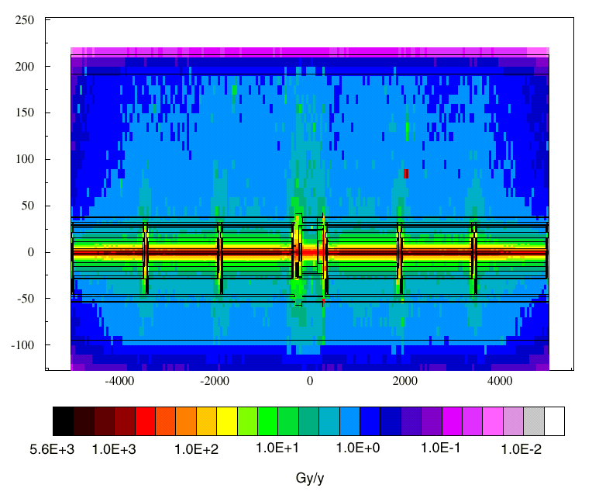
Figure 2 : Dose rates under the magnets in a ARC cell

The highest dose rates are expected between dipoles and quadrupoles and the neutron and hadron flux is also expected to reach a local maximum there. The table below summarises on the radiation levels in the mid-ARC assuming a loss rate of 1.65 10¹¹ protons per meter per year for 2 beams [2].

Position | 1 MeV neutrons  [10¹¹ cm⁻²/y] | Hadrons (E> 20 MeV)  [10¹⁰ cm⁻²/y] | Dose  [Gy/y]
Dipole (d) | 1.1 | 0.7 | 2
Quadrupole (q) | 1 | 1 | 3
Gap d-q | 0.9 | 0.9 | 5
Gap q-d | 1.5 | 1.3 | 5

Table I : Radiation under the magnets of a cell in the mid ARC

In the ARC cells adjacent to the DS region (i.e. C13, C15 and C17), radiation levels will increase gradually to those expected for the DS.

Local distribution – DS
The annual radiation levels in the Dispersion Suppressors are dominated by point losses and have been calculated assuming the point loss distribution described in [3]. The figure below shows the dose rate under the magnets in a DS hall cell (from Q11 to MB8B).
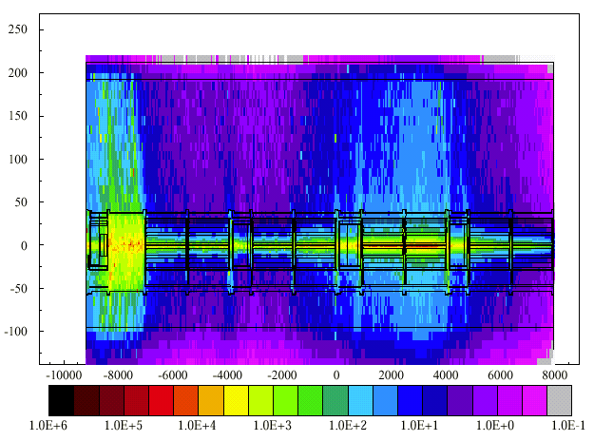
Figure 3 : Annual dose rates in the DS regions (from Q11 to MB8B)

The annual dose rate under the magnets is below 100 Gy but reaches a local maximum of 1 kGy per year in the q-d gap in Cell 11. The table below summarises on the radiation levels in the DS around point 5 which are similar to those found around point 1 (data from [1], [4]).

Position | 1 MeV neutrons  [10¹¹ cm⁻²/y] | Hadrons (E> 20 MeV)  [10¹⁰ cm⁻²/y] | Dose  [Gy/y]
MB8B | 2 | 1 | 3
MB8A | 5 | 4 | 9
Q8 | 8 | 6 | 15
MB9B | 59 | 43 | 100
MB9A | 30 | 22 | 50
Q9 | 18 | 12 | 30
MB10A | 11 | 9 | 20
MB10B | 7 | 5 | 12
Q10 | 5 | 4 | 10
MB11B | 7 | 71 | 12
MB11A | 12 | 118 | 20
gap | 144 | 57 | 900
Q11 | 72 | 120 | 800

Table II : Radiation under the magnets in the DS region around point 5

Local distribution – RR
The radiation in the RRs is caused by collision products (RR53, RR57, RR13, RR17) or losses in the collimators (RR73, RR77). As RRs will be shielded, the particle spectra will differ from those in the mid-ARC. The table below summarises on the radiation levels in the RRs around point 1 [5] which are expected to be similar to those in the RRs around point 5.

Position | 1 MeV neutrons  [10⁸ cm⁻²/y] | Hadrons (E> 20 MeV)  [10⁸ cm⁻²/y] | Dose  [Gy/y]
Ground floor  Shielding wall | 2.8 | 4 | 0.15
Ground floor  Tunnel wall | 2.4 | 2 | 0.15
First floor | 4.1 | 3 | 0.15

Table III : Radiation under the magnets in the DS region around point 1

Monte Carlo simulations for the RRs around point 7 are presently ongoing.

Functional specifications

Physical units
The radiation monitoring system will provide on line measurements of the following parameters :

- Total Ionising Dose in silicon expressed in Gray [joule/kg]
- 1 MeV equivalent neutron fluence expressed in neutrons/cm²
- Hadron fluence expressed in hadrons/cm²

When there is a circulating beam, the monitoring system will also provide on line measurements of the :

- Hadron flux expressed in hadrons/cm².second
- Ionising Dose rate in Gy per hour

INaccuracy, resolution

Inaccuracy is the long term measuring uncertainty taking into account the full range of permissible changes of operational and environmental conditions, calibrated in dedicated radiation facilities outside CERN against in house standards.

Resolution is the smallest increment that can be induced or discerned.

The range is the maximum value that can be measured.

Inaccuracy, resolution and range of the measurements are summarised in the table below.

 | Inaccuracy | Resolution | Range
Total dose [Gy] | ±10 % | 0.05 | 200
Neutron Fluence [n/cm²] | ±15 % | 1 10⁸ | 1 10¹⁴
Hadron fluence [h/cm²] | ±10 % | 1.7 10⁶ | 1.5 10¹¹
Hadron flux [h/cm².s] | ±12 % | 3.2 10⁶ | 2.3 10¹¹
Dose rate [Gy/hr] | ±10 % | 0.02 | 1

Table IV : Inaccuracy, resolution and range of the radiation monitors

heavy ions
When protons hit material, most particles will pass through causing little effect. Only a few protons will produce nuclear reactions and ionisation via recoils.

When heavy ions hit material, all particles will produce an ionisation track. Due to their very high energy transfer, ions have a much shorter range (or a high linear energy transfer).

This means that the radiation levels (and therefore the risk of radiation damage) in the tunnel during an ion run will be much lower than during a proton run and no particular properties need to be added to the present specification with respect to ion beams.

layout and number of locations to be monitored

The monitoring system will have 250 junction boxes distributed in the LHC tunnel and underground areas. The minimum number of radiation monitors that can be attached to a single junction box will be zero, the maximum number will be 32.

There will be a total of 125 radiation monitors that will all use the same electronic design. Any variation in the radiation tolerance of the monitors will therefore be minimised to the lot-to-lot variation of the components.

A single radiation monitor will use dosimeters with a varying sensitivity so that the inaccuracy, the resolution and the range of the measurements quoted in table IV are reached in every area.

At LHC startup, radiation monitoring in the RRs and the DS regions will have priority. The remaining monitors will be distributed in the ARCs and around IR4. A few monitors will remain available to accommodate requests from equipment groups.

Global layout

The figure below shows the location of the junction boxes for the radiation monitoring system around the machine.

Figure 4 : Global layout of the Radiation Monitoring system

The ARCs are only partially covered as the risk of inducing radiation damage to equipment is lower during LHC start up. However, an extension of the system to cover the entire ARCs should be anticipated in case this is decided upon during the LHC commissioning phase.

Local layout
In the ARCs, there will be one junction box per half cell. If a monitor is attached to the junction box, the default location of the monitor will be under the cryostat of the quadrupole of the half cell.

The local cabling will allow a displacement of each monitor over a maximum distance of 25 meters with respect to the junction box so that radiation levels can be measured at virtually any location along the entire length of the cell without difficulty.

In the DS, there will also be one junction box per half cell. The default location of the monitor will be under the cryostat of MBXXa or MBXXb, next to the Quench Protection equipment (DYPB or DYPQ). In case this equipment is absent, the default location will be next to the electronics for the Beam Position/Loss Monitors (BYPM).

In the RRs around point 1 and 5, there will be 3 monitors : two against the shielding wall on either side of the RR and one centred at the first floor. The RRs around point 7 will have 2 monitors at either side of the RR.

More details on the layout can be found in [6].

Data handling
The radiation monitoring system will use standard controls hardware and software similar to that used for all other distributed systems in the tunnel.

The radiation monitoring system will be entirely database driven.

The system will be able to generate alarms.

Calibration and settings
Calibration curves for each monitor will be loaded from a database before filling the LHC. This database will also contain the exact location of each monitor at that moment.

The level at which an alarm will be raised will be stored in the same database. The default values will correspond to three times the quench level of a superconducting magnet.

Data processing
All data will be processed and stored in real time in the LHC logging database. The minimum rate for data processing will be 1 Hz. The maximum rate will not exceed 2 Hz.

Graphical interface
The data of the monitoring system will be made visible in the control room via a Graphical User Interface. The interface should allow combining data from the beam loss monitoring system and the quench protection system to provide a coherent view of the radiation levels around the ring to the engineer in charge.

The graphical interface will also provide the possibly to visualise cumulative radiation levels at the location of the equipment between fills.

References
[1] C. Fynbo, G. Stevenson, “Radiation Environment in the main ring of the LHC”, LHC Project Seminar, November 2001.
[2] K. Potter, H. Schönbacher, G. Stevenson, LHC-Project-Note-18, Geneva, CERN, 24 Nov 1995.
[3] I. Baishev, LHC-Project-Note-240, Geneva, CERN, 01 Dec 2000.
[4] C. Fynbo, G. Stevenson, LHC-Project-Note-296, Geneva, CERN, 07 May 2002.
[5] http://lhc-radwg.web.cern.ch/LHC-radwg/LHC_Radiation_Studies/RR_IB1404.pdf
[6] http://lhc-ceiwg.web.cern.ch/LHC-ceiwg/Infrastructure/Layouts.htm

